**Security Assessment**

**Please read the instruction carefully before you start the security assessment and it is mandatory for you to capture the unique id which is generated by the system after completion of the assessment.**

Step 1:

Double click on the following embedded file.



Step 2:

Once you click on the above embedded file, the following POP up will appear, click on open.

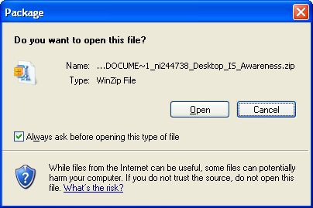

Step 3:

Once you click on OPEN button, the following screen will appear. Click on **EXTRACT** which is highlighted in the below picture.

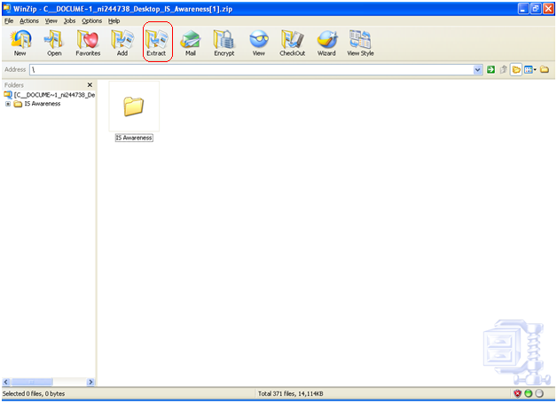

Step 3:

Once you click on Extract it will ask for the location where it has to be saved (it is recommended to save on the desktop).

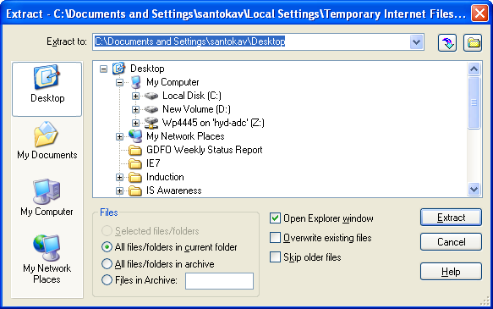

Step 4:

Open the file which you have saved and double click on the Exe file which says **DtRT_4** as show below.

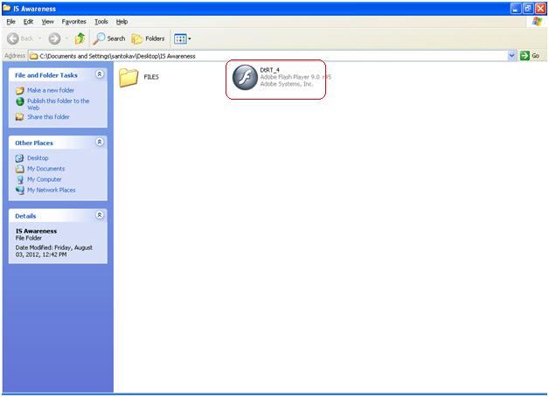

Step 5: Click on run to start with the security assessment.

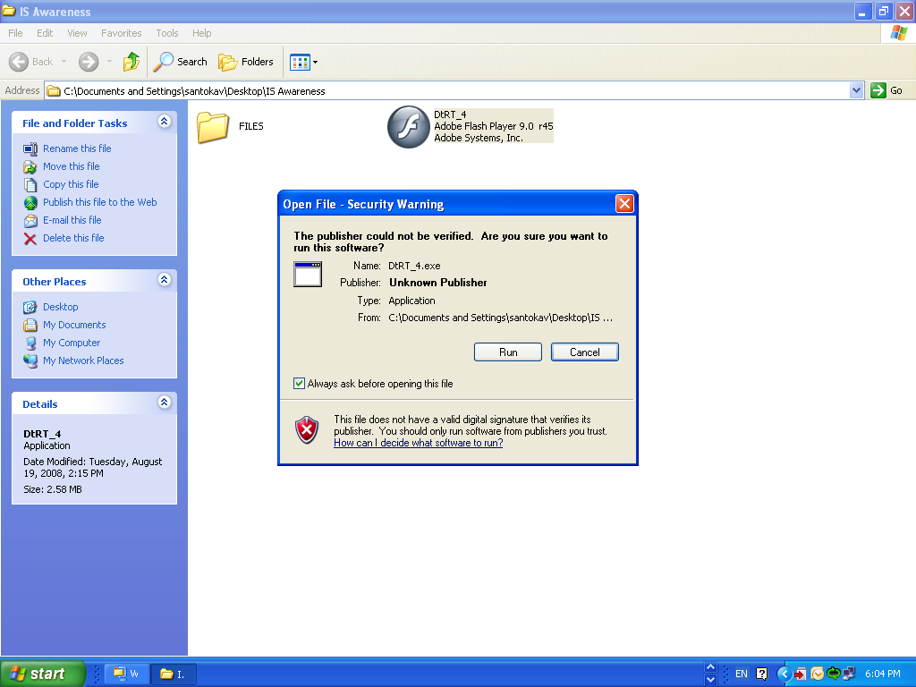

Step 6: Below is the first screen which you appear for you, follow the instructions and complete the security assessment.

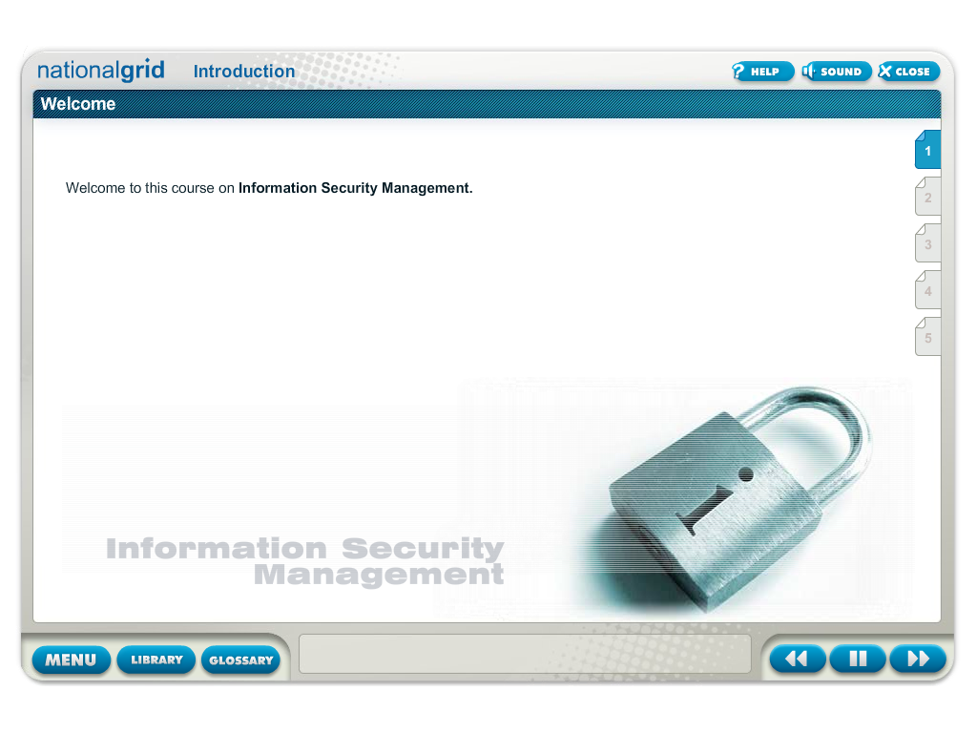

Step 7: Once you have completed the security assessment you will get the unique id as shown in the following screen, which you have to note it down and update the same in the shine site under mentee comments and change the % completion to 100% as shown in the following screen **failing which the security assessment will be considered as incomplete.**

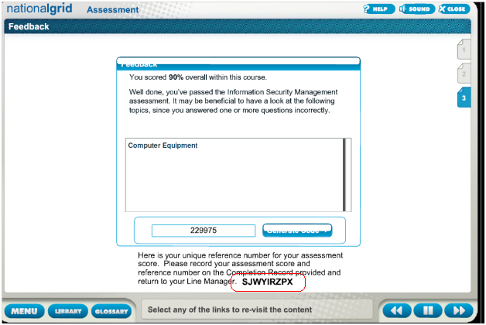

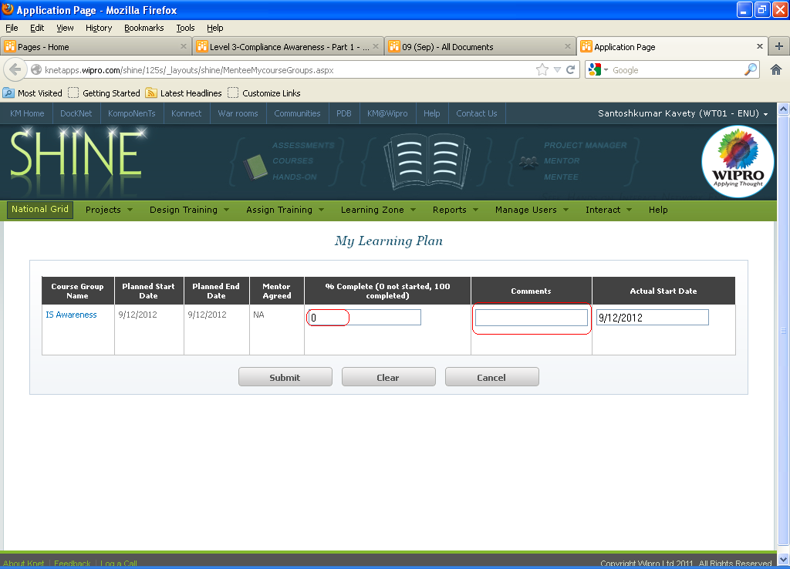

Thank you, This action completes your assesement.